Roll No: 2103064

Lab Performance Evaluation 01
Lab Task Q1
Question: Circuit Design with STM32 based embedded system which takes 1 input via push down button for RED light when button is pushed and GREEN Light when Button is not pushed.

Solution (Code):
// Roll-2103064
int Button=PB10;
int Red=PB0;
int Green=PB1;

void setup() {
// put your setup code here, to run once:
// pinMode(PC13, OUTPUT);
pinMode(Green, OUTPUT);
pinMode(Red, OUTPUT);
pinMode(Button, INPUT);

}

void loop() {
// put your main code here, to run repeatedly:
if (digitalRead(Button)==LOW)
{
digitalWrite(Green, LOW);
digitalWrite(Red,HIGH);
}
else
{
digitalWrite(Red, HIGH);
digitalWrite(Green, LOW);
}
}

Output (Pics of Breadboard):
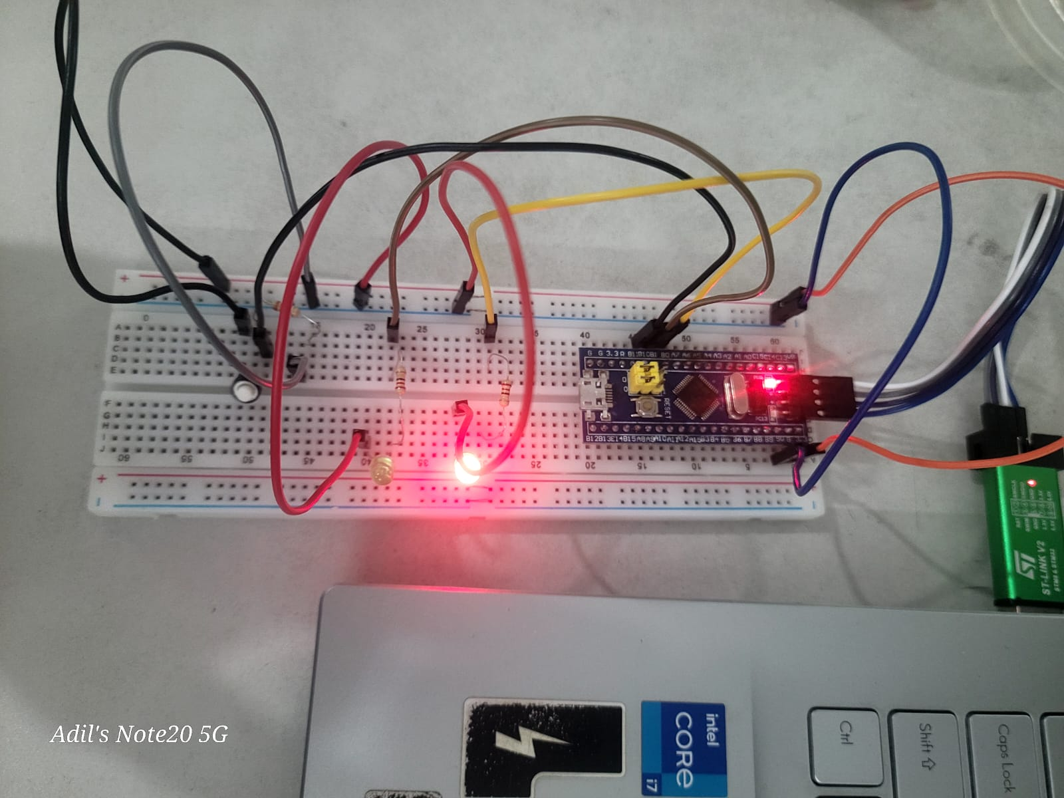

Lab Performance Evaluation 01
Lab Task Q2
Question: Circuit Design with STM32 based embedded system which takes 1 input via Potentiometer and gives output via 2 LEDs. For 1st half range the RED light will be on and its brightness changes, for the second half range the Green light will be on and its brightness changes.

Solution (Code):
// Roll-2103064
const int POT = PB0; // Potentiometer connected to A0
const int LED = PB1;
const int Green=PB10; // LED connected to PWM pin 9

void setup() {
pinMode(LED, OUTPUT);
pinMode(POT, INPUT);
}

void loop() {
int potValue = analogRead(POT); // Read potentiometer (0–1023)
potValue = map(potValue, 0, 1023, 0, 255);
potValue=constrain(potValue,0,255); // Map to PWM range
// analogWrite(LED, pwmValue); // Set LED brightness
// delay(10);
if(potValue<128)
{
analogWrite(Green,0);
analogWrite(LED,potValue*2);
}
else {
analogWrite(LED,0);
analogWrite(Green, (255-potValue)*2);
}
delay(10);
}

Output (Pics of Breadboard):

